[1]Description of the problem

PowerEnjoy is a car sharing service that exclusively employs electric cars. The company is in need of a system that allows users to find the locations of available cars located in the geographical areas they choose to explore. Then, they may complete the reservation of a car among those found with the research tool. After that, if the user who made the reservation launches the car doors unlock command and PowerEnjoy detects he is nearby, then the car doors are actually unlocked.

During the ride, the driver is notified of the current bill in real-time through the screen. At the of the ride expenses are automatically charged on the driver’s count. Since all the vehicles are electric, it is fundamental to keep them properly charged, so the users will be incentivized in being virtuous through discounts and penalty fees. A saving option will be provided in order to help users make the right choices both to save money and to help the PowerEnjoy maintain its high quality service.

Goals

PowerEnjoy has to provide these main features:

* [G1] Let users drive a car for a fare when needed.
* [G2] When a user wants to use a car, nobody else can use that car at the same time.
* [G3] Let users find and reach cars.
* [G4] Let drivers find and reach safe parking areas and locations.
* [G5] Encourage the share of a single car.
* [G6] Most of the time cars have battery level such that they can be used.
* [G7] Cars are always well distributed on the territory.
* [G8] Make sure that most of the cars are ready to use and in a good condition.
* [G9] Identify who drives for security purposes.

Domain properties

We suppose that these properties hold in the analyzed world:

* [D1] Sign up personal information is true.
* [D2] Cars are always connected to PowerEnjoy VPN (Virtual Private Network).
* [D3] Cars’ GPS is never neither switched off nor damaged.
* [D4] Cars’ locations are known by GPS.
* [D5] Users who have an open reservation are properly located by GPS through their mobile devices.
* [D6] Payment issues are delegated to a third-party company.
* [D7] All sensors report correct information and they are neither switched off nor damaged.
* [D8] All possible technical issues are detected by the sensors.
* [D9] Each power plug can be linked to one and only one car at the same time.
* [D10] Power grid stations always dispense electricity.
* [D11] Cars’ screens are never switched off nor damaged.
* [D12] The number of available slots in a special parking area is always known by PowerEnJoy though his VPN.
* [D13] The user who inserts his password on the screen is the same who actually drives the car.

Glossary

In this paragraph, we go through some recurrent terms that deserve a complete definition to avoid misunderstandings along the discussion:

* **Budget**: maximum amount of money acquirable from the payment information.
* **Car**: the electric vehicles considered available by the stakeholders.
* **Company**: people who work to.***
* **Discount**:
  + **A**: PowerEnJoy detects the user took at least two other passengers onto the car -> 10% discount on the last ride.
  + **B**: the car is left no more than 50% of the battery empty -> 20% discount on the last ride.
  + **C**: the car is left in a special parking area and it is plugged to a power grid station before ending the ride -> 30% discount on the last ride.
* **Driver**: user that ignites the engine of the car.
* **Fee**:
  + **A**: a user makes a reservation but he does not unlock the car doors within one hour from the reservation -> 1 €.
  + **B**: the car is left at more than 3 km from the nearest power grid station or with more than 80% of the battery empty -> 30% fee on the last ride.
  + **C**: a user who unlocks the car doors does not ignite the engine within 5 minutes. -> 1 € / min until he ignites the engine.
* **Guest**: we use this term when referring to an unlogged user.
* **Operator**: person who works for the company in order to give support to the drivers*.
* **Passenger**: person who enter the car.
* **Payment information**:
  + Payment method name
  + Surname and name of the owner
  + Card number
  + Valid through date
  + CVV
* **Personal information**:
  + Surname and name
  + Nationality
  + Date of birth
  + City of birth
  + Personal ID
  + Phone number
  + E-mail address
  + Username to log in
* **Power grid station**: the energy turrets where the users can leave cars to refill their batteries.
* **Power plug**: it is about a power plug located in exactly one power grid station.
* **Reservation**: service concerning the possibility to exclusively reserve a car for a user.
* **Ride**: time between the engine ignites and the car doors’ get locked.
* **Safe parking area**: a parking area included by PowerEnJoy in a list of legal places to leave cars at. Safe parking areas are the only places where a car can be parked in order to end the ride.
* **Screen**: system terminal connected to the central one used in order to communicate to the driver.
* **Special parking area**: we use this expression to point out a subset of safe parking areas where a power grid station is present.
* **Technical issue**: concerns mechanical and electrical problems, empty battery level during a ride and collisions.
* **User**: person who provided personal and payment information which have been verified and recognized. User has access to the full set of PowerEnJoy’s services.

Assumption

There are few points that are not very clear in the specification document, so we will have to assume some facts. We assume that:

* A guest can only register, surf the list of available cars on the map and consult the service’s rules.
* The A discount can be applied if and only if the number of passengers is greater or equal to three, both at the beginning and at the end of the ride.
* Each special parking area is associated to one and only one power grid station.
* Each power grid station has exactly one power plug.
* Insurance renewal is company’s administration competence.
* Road fines are affair between traffic corps and company’s legal department.
* The validity of the driving license number associated with the user’s profile will have to be verified by the driver licensing authority.
* The validity of the payment information associated with the user’s profile will have to be verified by the payment company.
* Once a request is made, the user may cancel it.
* Payments are charged at the end of each ride.
* Despite the possibility of encouraging users to behave well, periodically an operator will take care about cars’ repositioning.
* A driver cannot temporary park his car and exit from it [1].explain why this choice.***
* A discount regarding power grid stations is applied if and only if the car is in a special parking area and the car is actually charging.
* The set of special parking areas is pre-defined in PowerEnJoy.
* Cars’ batteries are considered almost empty when they reach 20%.
* A user who unlocks the car and does not ignites the engine within 5 minute has to pay the C fee. Indeed, he is encouraged to ignite the engine sooner or later.
* Power grid stations are located only in special parking areas.
* On the car’s power plug there is a safety lock.
* Locking and unlocking car doors means that also the power plug on the car is safety locked or unlocked.
* Cars’ windows close automatically when a ride ends.
* There are sensors in order to detect whether a person is sitting or not in the car seats.

[1] It is important to remark that a possible improvement to PowerEnjoy would provide this functionality. However it may be though as a future extension to the one with all the necessary functionalities.*

Proposed system

The best solution to carry on the project is to develop a web platform, both in the form of a website and of a mobile application. The requisite of portability is fundamental, since one of the wanted features is the that cars should be found opened and ready to serve when they are near enough. A plugin for wearable devices could also serve to this functionality. *what will we use to make it possible to use the system? / hardware and software of machines*

Stakeholders

The one and only stakeholder for this project is represented by the professor who defined the assignment. The deadline for the submission of the complete document is the end of the current semester. The final submission should provide a clear and complete documentation for the development of the system, along with use cases analysis and tests.

The completeness of the document will be compromised by the need of focusing on the major features of the system. Nonetheless we’ll try to maintain a high level of consistency all along the dissertation and to develop as many aspects as possible.

Concerning the target of the application, we can think of the standard user as a stable user: the aim of PowerEnJoy should be to convince the customers to use it more than just once.

Other considerations about the system

Some considerations based on the last sentence in the previous paragraph can be made. If the aim of PowerEnJoy is to be used daily, a great effort must be spent on the user experience, in particular we require the following characteristics:

• Usability: since the set of functionalities usable by the user is quite limited it should not be difficult to make them so intuitive that no documentation will be necessary to fully understand them at a first glance

• Security: the manipulation of sensible data like payment methods requires a strong focus on security matters and the customers must be aware that they are placing their money in good hands

• Stability: it’s a major characteristic since the service must be available h24 7/7dd

• Look & feel: an essential design is necessary to catch the customers’ attention and bound them to the service

Actors identifying

The actors involved in PowerEnJoy are:

• Guest: a person who can access a limited number of the PowerEnJoy’s features, e.g. the research tool. They can neither make reservations nor access to any features that require the possibility of online payments*.

• User: a person who has registered and therefore has provided his personal and payment information.

• Driver: a user who has made a reservation for a car and now is driving it.***

• Operator: a person who takes care of cars’ maintainability both for technical and legal issues.

Requirements

Thinking that the domain properties, written in paragraph 1.3, holds, from the goals, written in paragraph 1.2, we can derive our requirements. We write below, for each goal, what we can derive:

Thinking that the domain properties, written in paragraph 1.3, holds, from the goals, written in paragraph 1.2, we can derive our requirements. We write below, for each goal, what we can derive:

1. **[G1] Let users drive a car for a fare when needed.**
   1. [R1] Sign up functionality.
   2. [R2] Verification of driving license and payment information.
   3. [R3] Log in functionality.
   4. [R4] Prevent car doors from unlocking unless the user is into a 10m range.
   5. [R5] Start counting expenses for a given amount of money per minute, as soon as the engine ignites.
   6. [R6] Charge expenses on the user’s account after the end of each ride.
   7. [R7] Consult last rides’ invoices.
2. **[G2] When a user wants to use a car, nobody else can use that car at the same time.**
   1. [R1] Make reservations valid for a single car at the same time.
   2. [R2] The reservation expires by one hour and the A fee is charged, then the car is available again.
   3. [R3] Reserved cars are marked as unavailable.
   4. [R4] Lock car doors after each ride.
   5. [R5] Stop counting expanses when a ride terminates and generate the invoice.
   6. [R6] Restore cars’ availability after each ride.
3. **[G3] Let users find and reach cars.**
   1. [R1] Find cars located nearby or specifying an address.
   2. [R2] Navigate to a reserved car.
4. **[G4] Let drivers find and reach safe parking areas and locations.**
   1. [R1] Guide each driver to a chosen location.
   2. [R2] If money saving option is enabled, then guide the driver to a special parking area according to driver’s final destination.
5. **[G5] Encourage the share of a single car.**
   1. [R1] Apply the A discount.
6. **[G6] Most of the time cars have battery level such that they can be used.**
   1. [R1] View special parking areas.
   2. [R2] Apply the B discount.
   3. [R3] Apply the C discount.
   4. [R4] Periodically, if there is an almost empty battery level car, a notification will be sent to operators who will intervene.
   5. [R5] Restore cars’ availability once at least 20% battery level is reached.
   6. [R6] Charge the B fee.
   7. [R7] Enable money saving option.
7. **[G7] Cars are always well distributed on the territory.**
   1. [R1] Charge the B fee.
   2. [R2] Periodically, if there is a non-uniform cars’ distribution, a notification will be sent to operators who will intervene.
   3. [R3] View special parking areas.
   4. [R4] Enable money saving option.
8. **[G8] Make sure that most of the cars are ready to use and in a good condition.**
   1. [R1] When a technical issue is detected, a notification will be sent to operators who will intervene and the car is switched to unavailable.
   2. [R2] Make a report whether a minor issue has been discovered by the driver.
   3. [R3] Periodically, an operator will take care of managing reported minor issues.
9. **[G9] Identify who drives for security purposes.**
   1. [R1] The user who unlocks the car doors must enter his personal password once in the car in order to be recognized.
   2. [R2] Every time the user wants to ignite the engine, he must be recognized.
   3. [R3] Every time the driver exits the car, the engine goes off after 15 seconds.
   4. [R4] A operator can in every moment watch all drivers driving a certain car and in case of necessity he can send this information to recognized external authority (like police and or medical services). **** add scenario per questo
   5. [R5] The user can ask for a new password.
   6. [R6] A ride can last for at most eight hours. After that, the public safety is informed about a potential robbery.

Scenario identifying

Scenario identifying

**Scenario 1**

Juan has planned a day trip to a museum with three friends of him. Since the museum is in the same city as them, Juan wants to get to the museum using PowerEnJoy, so he signs up and searches for a car. After some minutes, he receives an e-mail containing his new password, which he finds too difficult to remember, so he asks for a new one through the app functionality. To be well prepared for the event, he also searches for the nearest special parking area through the app functionality. Half an hour before the meeting, Juan reserves a car and uses the “navigate to the car” functionality to get to the right location along with his friends. When everybody is there, he uses the “unlock doors” button to open the car doors, then they board together. Juan is asked to insert the password that was provided by the system at the moment of the registration, then he ignites the engine and searches for the destination through the car’s screen. Juan presses the “money saving option” button on the screen to be informed of the upcoming discounts, then he starts driving to the selected location. When Juan arrives at the selected location he parks into a safe parking area, all the passengers get off the car and the doors lock. Ten minutes later, Juan is notified of the new invoice and he consults the final expenses for the ride.

**Scenario 2**

After Christmas holidays there are several cars that are located in areas that are very far from safe parking areas. A notification is sent to one of the operators of PowerEnJoy requesting his intervention to bring one of the vehicles back to the nearest special parking area. After the operator has completed the task another notification arrives claiming that a car was left unplugged with 5% battery, so he heads to the location of the vehicle and recharges it with the emergency kit he’s provided with, then he boards on the car and brings it back to nearest safe parking area and makes sure the battery is at least 10% recharged.

**Scenario 3**

Julia has a reservation for a car but when she arrives at the vehicle’s location she finds out the cabin is dirty. She presses the “report an issue” button on the car screen and retires the reservation through the app. After a short time, an operator pushes the “show reported issues” button and takes the issue in charge. After he has opened a new paperwork, he uses the “find rides by plate number” to check who used the car the last time, then he heads at the car’s location and resolves the issue requesting aid from the central. Being the problem not that grave, no notification is sent to the responsible, but the operator still produces a report for the issue using the “create a report” functionality.

**Scenario 4**

One day a vandal breaks the glasses of a parked PowerEnJoy car. The system detects the issue and a notification is sent to an operator, who takes the problem in charge and immediately heads to the car’s location. After he has checked the car’s conditions he brings it to the affiliate mechanic to repair the damage.

**Scenario 5**

Anthon has boarded a car with his girlfriend to go to the cinema. They rush out the car to arrive in time for the show, but doing so Anthon parks in a safe parking area leaving the engine ignited. To make things worse, the car’s battery is at 7% when Anthon and his girlfriend get off and the nearest power grid is 5km away from the car’s location. In the interval, Anthon checks the invoice that was generated for the ride and he discovers not only that he has no right to any discount, but that he also must pay fee C.

**Scenario 6**

At three o’clock p.m. a notification for a technical issue (a pneumatic brake) appears on the page of an operator. He starts the procedure by marking the car as unavailable but, doing so, he finds out that the car was reserved in the meanwhile. The operator waits for the ride to end, then the car is finally marked as unavailable and he heads to its location. When the operator arrives, he discovers that the car’s insides are not as clean as they should, so he resolves both the issues and writes down in the report the actions he performed.

Use Case

|  |  |
| --- | --- |
| **Actor** | Guest |
| **Goal** | [G1] [R1] [R2] |
| **Precondition** | - |
| **Event Flow** | 1. A guest on the home page presses the “sign up” button to start the registration process. 2. The guest fills the form with personal, payment and driving license information. 3. The guest verifies and confirms information entered. 4. PowerEnJoy forwards driving license information to the driver licensing authority which will validate them. 5. PowerEnJoy forwards payment information to the payment company which will validate them. |
| **Post-Condition** | The guest receives a password generated by PowerEnJoy to log in via e-mail.  The guest can now log in PowerEnJoy.  All his information is stored. |
| **Exception** | 1. A guest fills the form with information regarding another user. 2. The driving license information has not been validated. 3. The payment information has not been validated. |
| **Exception Handling** | (a), (b), (c) The signing up process is aborted and the guest is notified via e-mail. |

DIAG G1 R1R2

|  |  |
| --- | --- |
| **Actor** | Guest |
| **Goal** | [G1] [R3] |
| **Precondition** | - |
| **Event Flow** | 1. A guest on the home page presses the “log in” button to use PowerEnJoy’s features. 2. The guest fills basic personal information and the password given by PowerEnJoy. |
| **Post-Condition** | The guest is now logged in PowerEnJoy.  The guest becomes a user. |
| **Exception** | 1. Either basic personal information or password is wrong. |
| **Exception Handling** | (a) Ask the user to refill both basic personal information and the password. |

|  |  |
| --- | --- |
| **Actor** | User |
| **Goal** | [G1] [R4] [R5] [G9] [R1] [R2] |
| **Precondition** | The user has an active reservation for a car. |
| **Event Flow** | 1. The user launches the car doors unlock command. 2. PowerEnJoy detects the user’s position using the GPS. 3. PowerEnJoy unlocks car doors. 4. The user enters his password through the car’s screen. 5. PowerEnJoy recognizes the user. 6. The user ignites the engine for the first time. |
| **Post-Condition** | The ride starts.  The user becomes a driver.  Start counting expenses for a given amount of money per minute.  The driver can drive the car. |
| **Exception** | 1. The user is too far from the car. 2. The wrong password is inserted for five times. 3. The car is linked to a power turret. |
| **Exception Handling** | (a) Prevent car doors unlock.  (b) PowerEnJoy prevents further password insertion and the user has the possibility to exit the car within five minutes from the car doors unlock otherwise he starts paying the C fee. Then, the car doors lock, the reservation expires, the car status is switched to available and an invoice reporting expenses is generated.  (c) Once the car doors are unlocked, the user has also to unplug the car from the power turret, otherwise the engine does not ignite. |

DIAG G1 R4R5, G9 R1R2

UC G1

|  |  |
| --- | --- |
| **Actor** | User |
| **Goal** | [G1] [R6] [R7] |
| **Precondition** | The user has done at least one ride. |
| **Event Flow** | 1. PowerEnJoy charges expenses based on user’s payment information at the end of each ride. 2. PowerEnJoy creates an invoice related to last ride’s expenses. |
| **Post-Condition** | The user consults last rides’ invoices. |
| **Exception** | - |
| **Exception Handling** | - |

|  |  |
| --- | --- |
| **Actor** | User |
| **Goal** | [G2] [R1] [R2] [R3] |
| **Precondition** | The user has found an available car. |
| **Event Flow** | 1. The user presses the “make a reservation” button. 2. Reservation expiring timer starts. 3. The car is marked as unavailable. |
| **Post-Condition** | The user has reserved a car. |
| **Exception** | 1. Another user makes a reservation for the same car in the very short moment before so the car is actually unavailable. 2. The user does not start the ride within one hour. |
| **Exception Handling** | (a) The user may find another available car.  (b) The user has to pay the A fee and the reservation for the car expires. |

|  |  |
| --- | --- |
| **Actor** | Driver |
| **Goal** | [G2] [R4] [R5] [R6] |
| **Precondition** | - |
| **Event Flow** | 1. The driver parks into a safe parking area. 2. The driver turns off the engine definitively. 3. Every passenger gets off the car. 4. All doors are closed. |
| **Post-Condition** | PowerEnJoy locks car doors within one minute.  The ride ends.  The driver returns to be considered a user.  PowerEnJoy stops charging expenses.  PowerEnJoy generates the invoice corresponding to the ride.  The car is marked as available. |
| **Exception** | 1. The driver parks in a non-safe parking area. 2. One or more passengers do not get off the car. 3. Not all doors are closed. 4. The driver does not turn off the engine. 5. The car has almost empty battery. 6. The car is parked in a special parking area. |
| **Exception Handling** | (a), (b), (c) The car doors does not unlock and the ride does not terminate.  (d) The engine will be automatically switched off within 20 seconds as the driver exit.  (e) Car doors get locked, the ride ends but the car is marked as unavailable. PowerEnJoy charges the B fee unless it is parked in a special parking area.  (f) As the event flow below. In addition, the driver has to plug the car to the power turret otherwise the ride will not end. Then, all post-conditions above occur. |

|  |  |
| --- | --- |
| **Actor** | Guest / User |
| **Goal** | [G3] [R1] |
| **Precondition** | - |
| **Event Flow** | 1. A guest or a user on the home page presses the “look for a car” button to find a car. 2. The guest or the user fills the search filter searching for places of interest, address or actual position. 3. The guest or the user may consult cars’ status. |
| **Post-Condition** | PowerEnJoy finds out all the cars which match the search filter.  Cars’ status is available to be consulted. |
| **Exception** | - |
| **Exception Handling** | - |

|  |  |
| --- | --- |
| **Actor** | User |
| **Goal** | [G3] [R2] |
| **Precondition** | The user has an active reservation for a car. |
| **Event Flow** | 1. The user presses the “navigate to the car” button to reach the car. 2. The user selects a path according to his necessity. |
| **Post-Condition** | PowerEnJoy provides navigation tips to the user in order to reach the reserved car. |
| **Exception** | - |
| **Exception Handling** | - |

|  |  |
| --- | --- |
| **Actor** | Driver / Operator |
| **Goal** | [G4] [R1] |
| **Precondition** | - |
| **Event Flow** | 1. A driver/operator presses the “look for a destination” text area in order to navigate to a safe parking area near to a specific location. 2. The driver/operator fills the search filter according to places of interest or a specific address. 3. The driver selects a path according to his necessity. |
| **Post-Condition** | PowerEnJoy provides navigation tips to reach the target location. |
| **Exception** | - |
| **Exception Handling** | - |

|  |  |
| --- | --- |
| **Actor** | Driver |
| **Goal** | [G4] [R2] |
| **Precondition** | - |
| **Event Flow** | 1. A driver, on the screen presses the “money saving option” button. 2. The driver fills the search filter according to places of interest or a specific address. 3. The driver selects a special parking area among the ones near to the target location. 4. The driver selects a path according to his necessity. |
| **Post-Condition** | PowerEnJoy provides navigation tips to the driver in order to reach the nearest special parking area from the target location. |
| **Exception** | 1. While reaching the special parking area, it may happen that the target special parking area becomes full. |
| **Exception Handling** | (a) PowerEnJoy notifies the driver that the selected special parking area is not available anymore. Then, it evaluates another special parking area target. |

|  |  |
| --- | --- |
| **Actor** | Operator |
| **Goal** | [G6] [R4] [R5] |
| **Precondition** | PowerEnJoy detects an almost empty battery level car among those which are not charging and it notifies the operator. |
| **Event Flow** | 1. The operator accepts the notification. 2. The operator opens a new paperwork to manage the issue. 3. PowerEnJoy shows cars with low battery level. 4. The operator picks the car through a by-pass. 5. The operator moves the car to a special parking area. 6. The operator plugs the car to a power grid station. 7. PowerEnJoy will restore car’s availability when 20% level of battery is reached. 8. The operator closes the paperwork. |
| **Post-Condition** | A car is placed in a special parking area and it is charging. |
| **Exception** | 1. The car has a very low battery level and the operator can not move it to a special parking area. 2. In addition, the car has either a technical issue or a minor issue. |
| **Exception Handling** | (a) The operator reaches the car bringing with him a supply battery and plugs it. After an enough battery charge, the operator takes care of moving the car to a special parking area, to plug it and to restore the car’s availability.  (b) The operator will also take care of other problems according to the related routine procedure. |

|  |  |
| --- | --- |
| **Actor** | Operator |
| **Goal** | [G7] [R2] |
| **Precondition** | PowerEnJoy detects a non-uniform cars’ distribution among those which are not reserved and it notifies the operator. |
| **Event Flow** | 1. The operator receives notification. 2. The operator opens a new paperwork to manage the issue. 3. PowerEnJoy shows cars to be potentially re-distributed. 4. The operator selects a car and manually switches it to unavailable. 5. PowerEnJoy suggests a safe parking area where the car can be left. 6. The operator picks the car through a by-pass. 7. The operator moves the car to the suggested safe parking area. 8. The operator manually switches the car as available. 9. The operator closes the paperwork. |
| **Post-Condition** | A car is placed in a better safe parking area. |
| **Exception** | 1. A user makes a reservation for a car which has been shown in the list of cars to be potentially re-distributed before the operator selects it. 2. The car has either a low battery level, a technical issue or a minor issue. |
| **Exception Handling** | (a) PowerEnJoy warns the operator that the selected car has been reserved by a user. So, the operator is prompted to the list of cars to be potentially re-distributed.  (b) The operator will also take care of other problems according to the related routine procedure. |

|  |  |
| --- | --- |
| **Actor** | Guest / User / Driver / Operator |
| **Goal** | [G7] [R3] |
| **Precondition** | - |
| **Event Flow** | 1. An actor on the home page clicks on the “show special parking area” button. |
| **Post-Condition** | PowerEnJoy provides a list of all special parking areas. |
| **Exception** | - |
| **Exception Handling** | - |

|  |  |
| --- | --- |
| **Actor** | Operator |
| **Goal** | [G8] [R1] |
| **Precondition** | PowerEnJoy detects a technical issue and it sends a notification to an operator. |
| **Event Flow** | 1. PowerEnJoy marks the car as unavailable. 2. The operator accepts the notification. 3. The operator opens a new paperwork to manage the issue. 4. The operator evaluates the issue relevance. 5. The operator picks the car through a by-pass. 6. The operator, once in the car, may either launch the external tow truck service or move the car to the affiliate mechanical workshop according to the issue relevance. 7. After having fixed the issue, the operator brings the car to a safe parking area. 8. The operator restores car availability. 9. The operator closes the paperwork. |
| **Post-Condition** | The car is fixed up. |
| **Exception** | 1. The technical issue is detected while a user has reserved the car. 2. A user makes a reservation before the operator has marked the car as unavailable. 3. In addition, the car has either a low battery level or a minor issue. |
| **Exception Handling** | (a), (b) PowerEnJoy notifies the user/driver about it and it exhorts to cancel the reservation or end the ride. When the ride ends, the car is marked as unavailable. Then, the operator can proceed as explained in the event flow shown below.  (c) The operator will also take care of other problems according to the related routine procedure. |

|  |  |
| --- | --- |
| **Actor** | Driver |
| **Goal** | [G8] [R2] |
| **Precondition** | - |
| **Event Flow** | 1. The driver pushes the “report an issue” button through the car screen. 2. The driver fills relevant fields regarding the observed issue. |
| **Post-Condition** | The report is saved. |
| **Exception** | - |
| **Exception Handling** | - |

|  |  |
| --- | --- |
| **Actor** | Operator |
| **Goal** | [G8] [R3] |
| **Precondition** | The car is not reserved. |
| **Event Flow** | 1. The operator pushes the “show reported issues” button. 2. The operator selects all minor issues regarding a single car. 3. The operator opens a new paperwork to manage the car minor issues. 4. The operator switches the car as unavailable. 5. The operator picks the car through a by-pass. 6. The operator takes care of solving the minor issue. 7. The operator brings the car to a safe parking area. 8. The operator restores car availability. 9. The operator closes the paperwork. |
| **Post-Condition** | The car is clean and in a good condition. |
| **Exception** | 1. In addition, the car has either a low battery level or a technical issue. |
| **Exception Handling** | (a) The operator will also take care of other problems according to the related routine procedure. |

|  |  |
| --- | --- |
| **Actor** | Operator |
| **Goal** | [G9] [R4] |
| **Precondition** | - |
| **Event Flow** | 1. The operator pushes the “show ride information by number plate” button. 2. The operator selects details about a ride. 3. The operator selects the “create a report” button in order to create a summary document about that ride. |
| **Post-Condition** | A report of a ride is created. |
| **Exception** | - |
| **Exception Handling** | - |

|  |  |
| --- | --- |
| **Actor** | User |
| **Goal** | [G9] [R5] |
| **Precondition** | - |
| **Event Flow** | 1. The user pushes the “generate a new password” button on his profile settings. |
| **Post-Condition** | PowerEnJoy sends a new personal password associated to the user via e-mail. |
| **Exception** | - |
| **Exception Handling** | - |

Nonfunctional requirements

**User interface**

In this paragraph, we go through the main features of the user interface. In particular, we concentrate on the app’s most important pages and on the car screen.

Login page

The login page should be intuitive, without any functionality but to sign in or create a new account. A “home” button is provided to get to the main page and surf the available cars (without login).

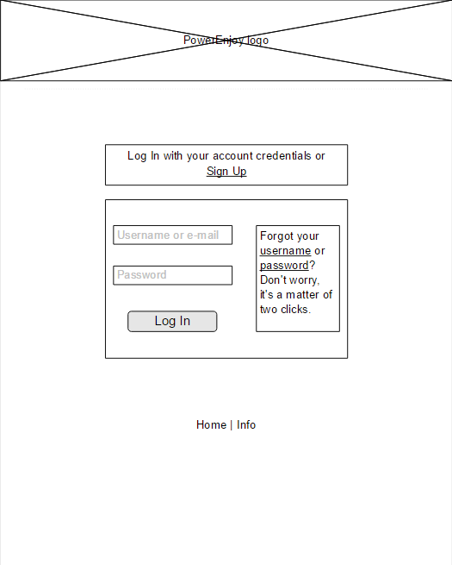

Account creation page

A scrollable page where new users can provide all the personal information necessary to create an account, comprehensive of a copy of the driving license. We must notice that in the following mockup not all the required information is represented (for example, a telephonic number is required). This was made only to make the representation clearer.

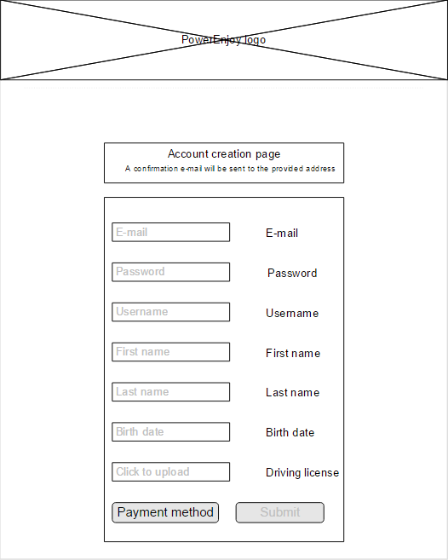

Main page

The main page of the application. Through this page it is possible to search all the available cars in the selected zones and, once a car is selected, to make a reservation for that car and start the navigation tool (powered by Google). The car doors unlock button is also in the main page, so that a user who gets to the car using the navigation tool can unlock the doors from the same page. Unlogged users can get to the main page, but all the buttons below the map will be unavailable.

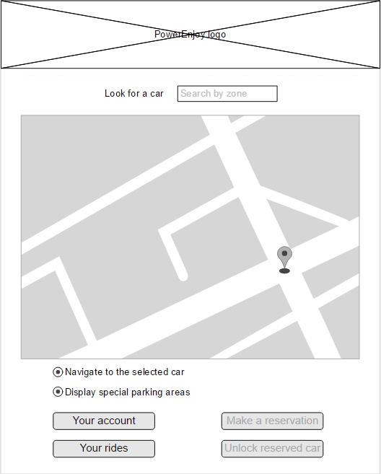

Car screen

The following picture represents the car screen after it has been unlocked through the personal password. The navigation system is powered by Google Maps, so we will not go through its complete functionality.

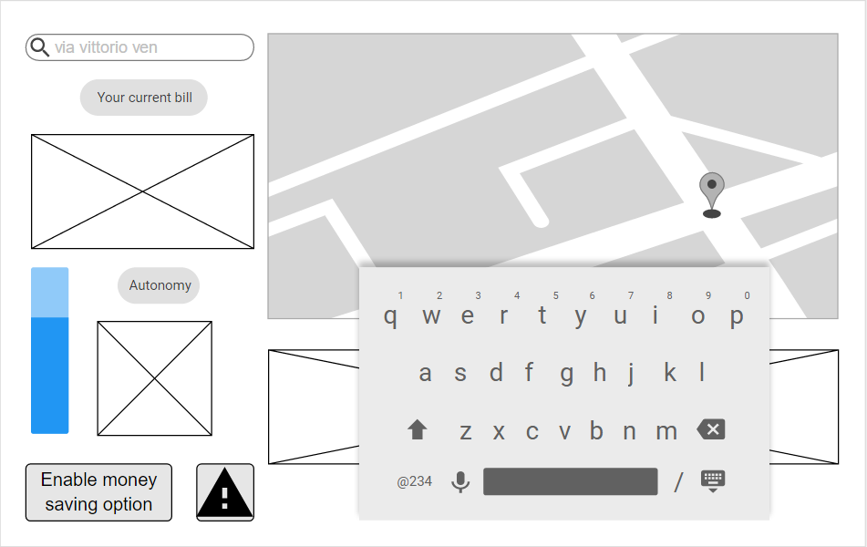

**Documentation**

The complete documentation for the project will consist of:

* RASD, Requirement Analysis and Specification Document, the present document, containing the description of goals and requirements along with a high level description of the proposed system. Technical properties are described through use case diagrams, UML diagrams and scenarios. The whole document
* DD, Design Document, containing the functional description of the system.
* Installation manual, containing the instructions necessary for the deployment of the system
* User manual, a complete description of the system from the point of view of the users
* Testing report, the description of the tests used to confirm the system’s reliability
* Project reporting, the result of analysis conducted during the development of the system

**Considerations upon reliability and availability of the proposed system**

The objective is to develop a system that ensures its service to be available H24 7/7. Since this goal is not obtainable in the real world, we plan to conduct all the necessary maintenance services during the night, when PowerEnJoy should be less requested, and with a large forewarning for customers. We plan to keep the maintenance services limited at one every two weeks, once PowerEnJoy is fully deployed.

Reliability is a fundamental characteristic of the system to be developed. The application in write-intensive. Every reservation is critical, since it requires access and blocking of resources that are normally accessible by everyone. The expected reliability rate is

1. ™